TASK 1

import org.junit.Assert;

import org.openqa.selenium.WebDriver;

import org.openqa.selenium.chrome.ChromeDriver;

import org.openqa.selenium.chrome.ChromeOptions;

import org.testng.annotations.Test;

import io.github.bonigarcia.wdm.WebDriverManager;

public class TESTNG {

*@Test*

public void f() {

WebDriverManager.*chromedriver*().setup();

ChromeOptions co=new ChromeOptions();

co.addArguments("--remote-allow-origins=*");

WebDriver driver=new ChromeDriver(co);

driver.get("https://demo.wpeverest.com/user-registration/guest-registration-form/");

driver.manage().window().maximize();

String t="Guest Registration Form – User Registration";

String t1=driver.getTitle();

Assert.*assertEquals*(t,t1);

}

}

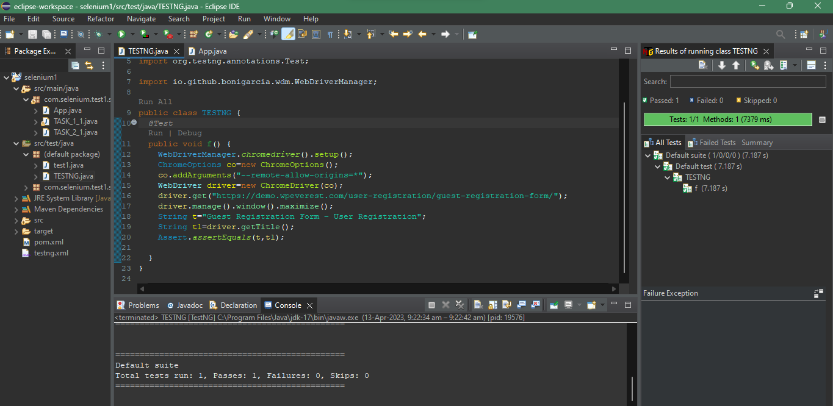

TASK 2

import org.testng.Assert;

import org.testng.annotations.Test;

public class task_7_2 {

int a=10,b=2,c;

*@Test*(priority=3)

public void add() {

c=a+b;

Assert.*assertEquals*(12,c);

}

*@Test*(priority=1)

public void sub() {

c=a-b;

Assert.*assertEquals*(8,c);

}

*@Test*(priority=4)

public void mul() {

c=a*b;

Assert.*assertEquals*(20,c);

}

*@Test*(priority=2)

public void div() {

c=a/b;

Assert.*assertEquals*(5,c);

}

}

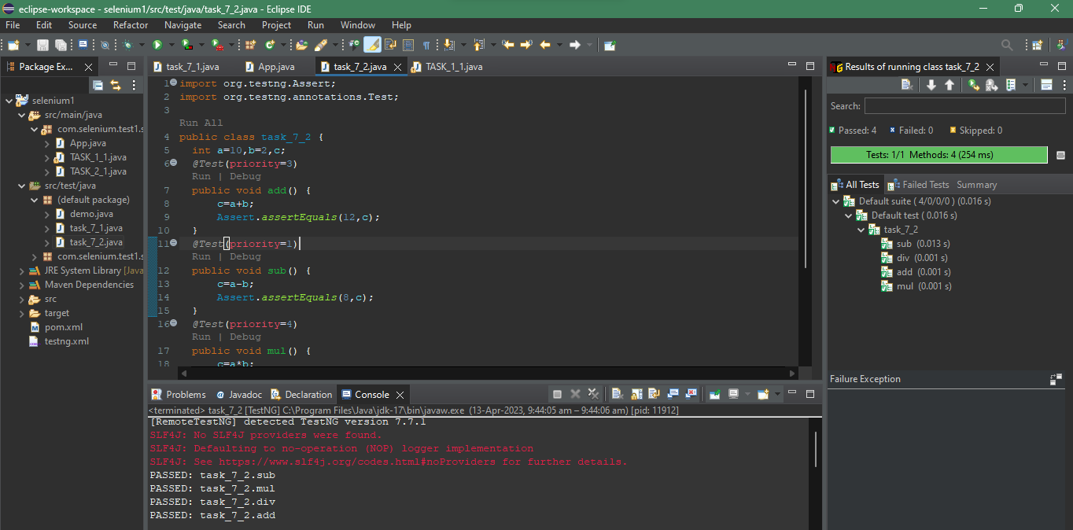

TASK 3

package com.selenium.test1.selenium1;

import org.testng.annotations.Test;

import io.github.bonigarcia.wdm.WebDriverManager;

import org.testng.*;

import org.testng.annotations.BeforeMethod;

import org.openqa.selenium.By;

import org.openqa.selenium.WebDriver;

import org.openqa.selenium.WebElement;

import org.openqa.selenium.chrome.ChromeDriver;

import org.openqa.selenium.chrome.ChromeOptions;

import org.testng.annotations.AfterMethod;

public class task_7_3{

WebDriver driver;

*@Test*

public void f() throws InterruptedException{

Thread.*sleep*(3000);

WebElement uname=driver.findElement(By.*name*("username"));

WebElement pwd=driver.findElement(By.*name*("password"));

WebElement submit= driver.findElement(By.*xpath*("//*[@id=\"app\"]/div[1]/div/div[1]/div/div[2]/div[2]/form/div[3]/button"));

uname.sendKeys("Admin");

pwd.sendKeys("admin123");

submit.click();

String url1="https://opensource-demo.orangehrmlive.com/web/index.php/dashboard/index";

String ActualUrl=driver.getCurrentUrl();

Assert.*assertEquals*(url1,ActualUrl);

}

*@BeforeMethod*

public void beforeMethod() {

WebDriverManager.*chromedriver*().setup();

ChromeOptions co = new ChromeOptions();

co.addArguments("--remote-allow-origins=*");

driver=new ChromeDriver(co);

driver.manage().window().maximize();

String url="https://opensource-demo.orangehrmlive.com/web/index.php/auth/login";

driver.get(url);

}

*@AfterMethod*

public void afterMethod()

{

driver.close();

}

}

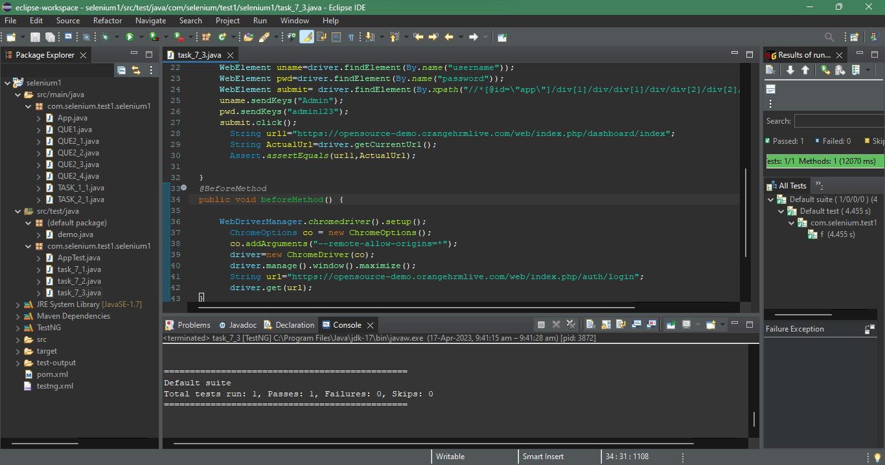

TASK 4

package com.selenium.test1.selenium1;

import org.openqa.selenium.By;

import org.openqa.selenium.WebDriver;

import org.openqa.selenium.WebElement;

import org.openqa.selenium.chrome.ChromeDriver;

import org.openqa.selenium.chrome.ChromeOptions;

import org.testng.Assert;

import org.testng.annotations.BeforeSuite;

import org.testng.annotations.Test;

import io.github.bonigarcia.wdm.WebDriverManager;

public class task_7_4 {

WebDriver driver;

*@BeforeSuite*

void init()

{

WebDriverManager.*chromedriver*().setup();

ChromeOptions co = new ChromeOptions();

co.addArguments("--remote-allow-origins=*");

driver=new ChromeDriver(co);

}

*@Test*

void Test1() throws InterruptedException

{ //open url and maximize

Assert.*assertEquals*(1, 1);

String url="https://opensource-demo.orangehrmlive.com/web/index.php/auth/login";

driver.get(url);

Thread.*sleep*(3000);

driver.manage().window().maximize();

//Entering uname, pwd and click login button

WebElement uname=driver.findElement(By.*name*("username"));

WebElement pwd=driver.findElement(By.*name*("password"));

WebElement submit=driver.findElement(By.*xpath*("//*[@class='oxd-button oxd-button--medium oxd-button--main orangehrm-login-button']"));

uname.sendKeys("Admin");

pwd.sendKeys("admin123");

submit.click();

}

*@Test*(dependsOnMethods = "Test1")

void Test2() throws Exception

{ //click profile option and click logout button

Thread.*sleep*(3000);

driver.findElement(By.*xpath*("//*[@id=\"app\"]/div[1]/div[1]/header/div[1]/div[2]/ul/li/span/p")).click();

Thread.*sleep*(3000);

driver.findElement(By.*xpath*("//*[@id=\"app\"]/div[1]/div[1]/header/div[1]/div[2]/ul/li/ul/li[4]/a")).click();

Thread.*sleep*(3000);

//verifying login page

String s1="OrangeHRM";

String s2=driver.getTitle();

Assert.*assertEquals*(s1, s2);

driver.close();

}

}

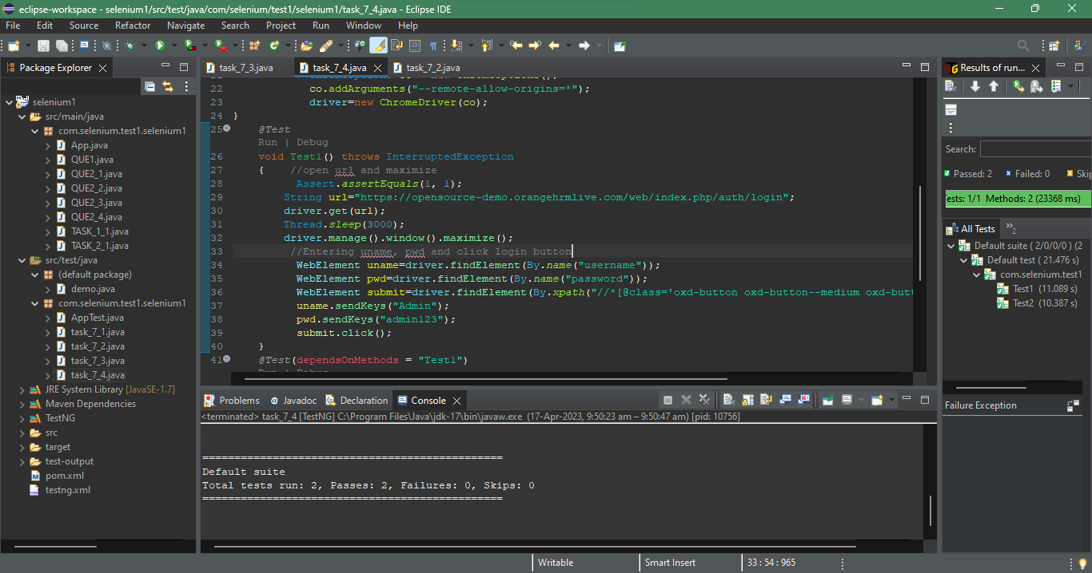

TASK 5

package com.selenium.test1.selenium1;

import java.util.concurrent.TimeUnit;

import org.openqa.selenium.By;

import org.openqa.selenium.WebDriver;

import org.openqa.selenium.chrome.ChromeDriver;

import org.openqa.selenium.chrome.ChromeOptions;

import org.testng.Assert;

import org.testng.annotations.Test;

import io.github.bonigarcia.wdm.WebDriverManager;

public class task_7_5 {

*@Test*(groups= {"SmokeTest"})

public void f() {

WebDriverManager.*chromedriver*().setup();

WebDriver driver;

ChromeOptions co = new ChromeOptions();

co.addArguments("--remote-allow-origins=*");

driver=new ChromeDriver(co);

driver.get("https://www.godaddy.com/en-in");

driver.manage().window().maximize();

String actualTitle="Domain Names, Websites, Hosting & Online Marketing Tools - GoDaddy IN";

String extractedTitle=driver.getTitle();

Assert.*assertEquals*(actualTitle, extractedTitle);

String actualURL="https://www.godaddy.com/en-in";

String extractedURL=driver.getCurrentUrl();

Assert.*assertEquals*(actualURL, extractedURL);

System.***out***.println("Smoke test");

driver.quit();

//driver.manage().timeouts().implicitlyWait(10, TimeUnit.SECONDS);

}

*@Test*(groups= {"RegressionTest"})

public void f1() {

WebDriverManager.*chromedriver*().setup();

WebDriver driver;

ChromeOptions co = new ChromeOptions();

co.addArguments("--remote-allow-origins=*");

driver=new ChromeDriver(co);

driver.get("https://www.godaddy.com/en-in");

driver.manage().window().maximize();

//driver.manage().timeouts().implicitlyWait(5, TimeUnit.SECONDS);

driver.manage().timeouts().~~implicitlyWait~~(10,*TimeUnit*.***SECONDS***);

driver.findElement(By.*xpath*("//*[@id=\"id-631b049a-e9c0-4d24-8710-c504745206dd\"]/div[2]/div[1]/ul/li[1]/button")).click();

driver.findElement(By.*linkText*("Domain Name Search")).click();

System.***out***.println("Regressiontest");

//driver.quit();

}

}

